TCS MICROPUMPS: MD450 with Inbuilt Driver
(Patents Pending, Quality Assured ISO 9001, RoHS compliant)
OVERVIEW
The MD450 pump is a high-quality miniature pump for liquids which is seal-less by design, eliminating one of the major failure points for conventional fluid pumps.
It is highly efficient, small and lightweight and features an inbuilt driver beneath the blue pump end cap.
The pumps performance is preset by TCS at the factory. Pump speed is dictated by input voltage. 6V will give the minimum flow rate and 12V will give the maximum flow rate.
OPERATION NOTES
Electrical connection –
Brown – Positive
Black – Negative
Operating Voltage –
- 6-12Vdc
NOTE – Strictly do not exceed 12Vdc. This will cause permanent damage to the pump driver.
Reverse polarity should NEVER be applied
The TCS inbuilt driver has NO reverse polarity protection. Reverse polarity will cause irreversible damage to the inbuilt driver.

GENERAL NOTES
- The pumping system MUST be fully purged of air before pump operation. Air in system will cause inconsistent pump performance.
- The inbuilt driver will change motor speed with applied voltage. 6V will provide minimum flow rate. 12V will provide maximum flow rate.

FLUID CONNECTION NOTES
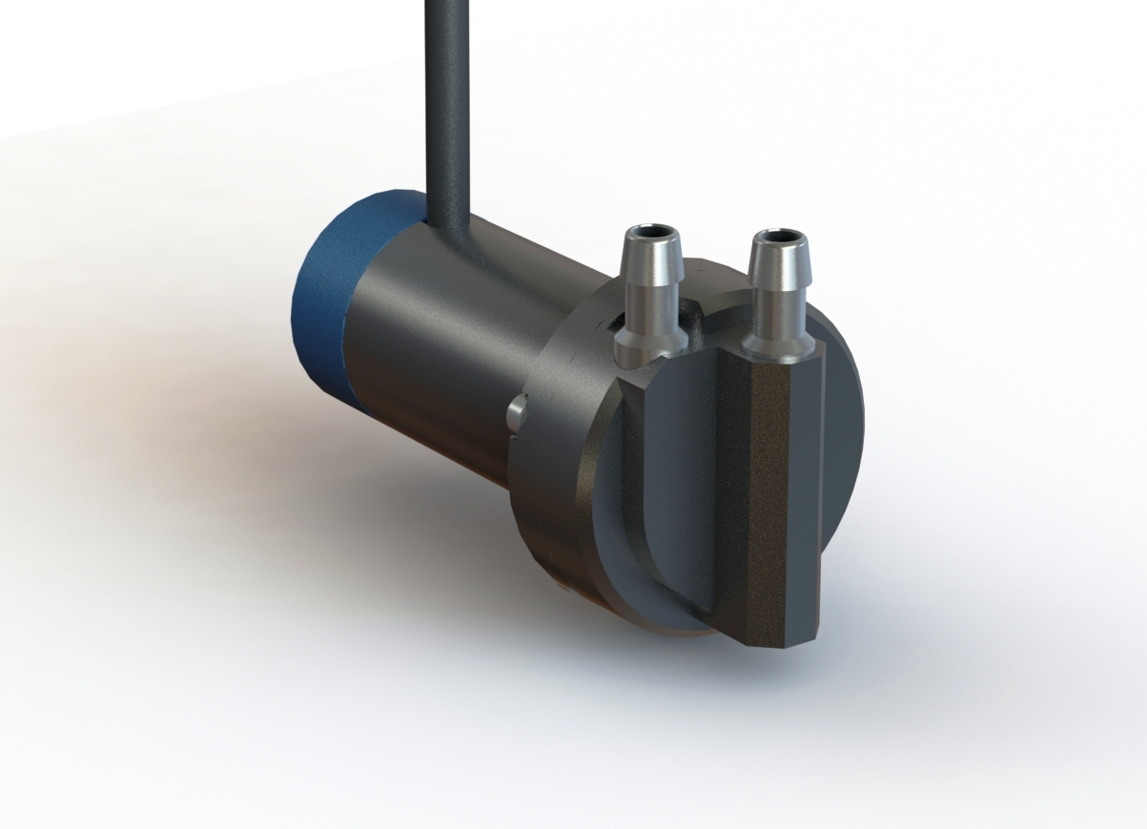
INLET
OUTLET

