TCS MICROPUMPS: D260BLX (RANGE)
(Patents Pending, Quality Assured ISO 9001, RoHS compliant, IP41 protection rating)

INTRODUCTION
The TCS D series Micropumps are high-quality self priming miniature pumps for gases. They are highly efficient, small and lightweight. The solid construction and wide temperature tolerance, enable them to perform reliably even in hostile environments. Your Micropump can be quickly and easily installed into the smallest spaces, in a vast range of laboratory, prototype and production equipment.

ELECTRICAL CONNECTION

CAUTION: REVERSED OR INCORRECT CONNECTION WILL PERMANENTLY DAMAGE THE ELECTRONICS IN YOUR PUMP!

Voltage: 3.0 to 6.0 Volts dc (Maximum 0.5Amps)

The simplest connection is Red, Green and Grey together to +ve (Positive) supply, Black to –ve (Negative) of supply

Wire Colour | Description | Connection | Status
Black | GRD  The negative connection | -Ve | Required
Grey | VM  Motor Power Supply | +Ve 3.0~6.0 | Required
Red | Vcc  Onboard Controller Supply Circuit | +Ve 3.0~6.0 | Required
Green | CW/CCW  Motor Rotation | +Ve 3.0~6.0 | Required
Yellow | RPM  Signal Wire | GND  Vcc 4 pulse / revolution  square wave signal | Optional
Your Micropump can be connected to batteries, a DC power source of up to 6V or a TCS power supply TCS-600 (see accessories page on website).

Pumping rate can be adjusted by varying input voltages between 3.0v and 6.0v dc. Further fine tuning can be made by restricting the outlet of your pump using a fixed jet restriction or flexible tubing and an adjustable clamp. The pump is quite happy to run even with the outlet completely blocked with gases.

Materials
Housing: Stainless Steel 316 (D260)
Tubing Connectors: Stainless Steel 316 (D260)
Seals: (Viton + Viton), (EPDM + EPDM), (Silicone + Nitrile), (Silicone + Viton)

TUBING
D200 series: 2.4mm (3/32”) bore flexible tubing

Notes on Operation
All ‘D series’ pumps are self priming by design. Simply connect the pump into your flow circuit, noting the flow direction shown below, and begin pumping.

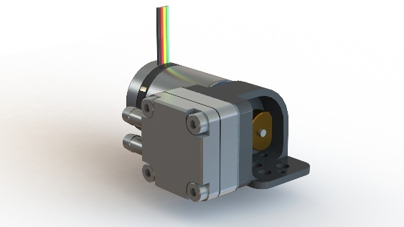

D260BLX

Performance | Input Voltage | Power Usage | Max Pressure | Max Free Flow
 | (v) | (w) | (psi) | (mlpm)
D260BLX - AIR | 3.0 - 6.0 | 0.1 - 0.6 | 11 | 550

Please note that figures above may vary depending on elastomers featured in pump.

