TCS MICROPUMPS: EQi-UART-M
Suitable for use with all versions of the M500 series Micropumps
(Patents Pending, Quality Assured ISO 9001, RoHS compliant)

INTRODUCTION
The TCS EQi-UART control board is a highly efficient, small and lightweight electronic brushless driver developed solely for the TCS range of brushless design micropumps. It can be quickly and easily installed into the smallest spaces, in a vast range of laboratory, prototype and production equipment.
The EQi-UART provides comprehensive pump control including onboard speed control, external speed control, on/off switching and direction control. The EQi-UART is pc compatible through the TCS UART interface it can be PC controlled, provide data feedback and offers programming customisation. For the PC interface connection optional accessory cable TCS-651 UART to USB 3v3 Cable must be purchased.
The EQi-UART will accept an input voltage of up to 6-28v DC. The speed control will be set to maximum from factory, the speed can be controlled by either the on-board speed control pot or from an external 0-4v control voltage. The flow direction can be reversed. The board can be switched on and off by an enable function.
The speed of the pump is 'Governed' above 12v to maintain a constant flow a constant RPM. This prevents the pump from being overdriven at higher input voltages.
The ability to hold a constant RPM when input voltage is increased provides a flatter pressure/flow curve in positive displacement pumps.
Below 12v the pump speed will decrease as the voltage is lowered.

ELECTRICAL CONNECTION
Voltage: 6-28V DC
Input: 2 screw terminal : UP to 28v/GND
Output: 3 screw terminal : Phase UVW

- Connect the 3 wires of the Micropump to the 3 screw terminals marked 'Phase UVW'.
- Connect the Input power to the 2 screw terminals marked 'Up to 28V (+) & GND (-)'.
- SET CONTROL MODE – The EQi-UART has two basic speed control options, onboard and external. The controller is preset in onboard mode from factory, this provides speed control by adjusting the potentiometer anti-clockwise to decrease speed/flow, clockwise to increase speed/flow (preset is maximum).
To activate the external control, the onboard potentiometer must be turned FULLY ANTI-CLOCKWISE. Once the potentiometer is fully anti-clockwise this will enable external control mode and the EQi-UART will reference the voltage input to the 0-4Vdc Control Input pin. 0-0.5Vdc is off 0.5V-4Vdc will provide linear speed control.
- DIRECTION CONTROL – The EQi-UART can switch the motor/flow direction. To enable this function simply to connect the 'Direction pin' to 'GND', this will reverse the motor/flow direction. When the pin is disconnected it will revert to the original motor/flow direction.
Please note direction control is pump model specific. Centrifugal style pumps (M500 series cannot flow in the reverse direction. Positive Displacement style pumps can flow in both directions (MGD Series, R Series).
- ENABLE ON/OFF CONTROL – The EQi-UART can control the ON/OFF Switching by pin input. To use the enable function (ON/OFF Switch) connect the ‘Enable pin’ to ‘GND’ this will turn the pump off. When the pin is disconnected the pump will be on.

TCS suggest that you begin testing with a supply voltage of 12v.
It is advised to use an 'always live' supply voltage as the EQi-UART is instant start. If a slow starting power supply is used it may cause the EQi-UART not to start the micropump. If this is the case then turn on PSU first and then connect the EQi.
Slow rise PSU’s can be overcome by implementing start delays through the TCS UART PC interface.
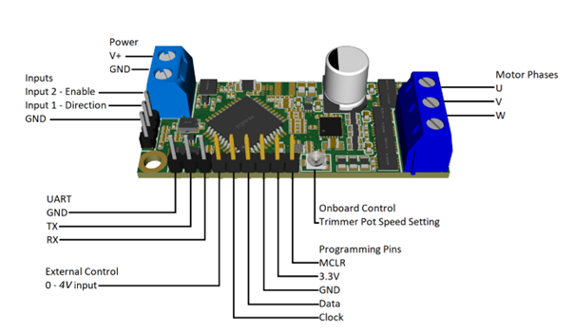
Wiring Diagram
Always make all connections before powering the EQi-UART.

(Red)
(Brown/Yellow)
(Black)

CAUTION
Do not exceed the maximum operating current draw of 2 amps.
Exceeding these limits may cause damage to the Micropump
The EQi-UART has a pre-programmed current trip. If maximum current is exceeded the controller will stop the micropump. To reactivate cycle the EQi-UART input power.

